Task P1-Batch June

**Task:-2**

import pandas as pd

import numpy as np

import matplotlib.pyplot as plt

from sklearn.cluster import KMeans

from sklearn.preprocessing import StandardScaler

# Load the dataset

df = pd.read_csv("/content/Mall_Customers.csv")

# Explore the dataset

print(df.head())

print(df.info())

# Preprocess the data

df.drop(['CustomerID', 'Genre'], axis=1, inplace=True)

scaler = StandardScaler()

scaled_data = scaler.fit_transform(df)

# Determine the optimal number of clusters

wcss = []

for i in range(1, 11):

    kmeans = KMeans(n_clusters=i, init='k-means++', random_state=42)

    kmeans.fit(scaled_data)

    wcss.append(kmeans.inertia_)

# Plot the elbow curve

plt.plot(range(1, 11), wcss)

plt.title('Elbow Method')

plt.xlabel('Number of Clusters')

plt.ylabel('WCSS')

plt.show()

# Apply K-means clustering

n_clusters = 5

kmeans = KMeans(n_clusters=n_clusters, init='k-means++', random_state=42)

kmeans.fit(scaled_data)

df['Cluster'] = kmeans.labels_

# Analyze the results

cluster_centers = scaler.inverse_transform(kmeans.cluster_centers_)

cluster_centers_df = pd.DataFrame(cluster_centers, columns=df.columns[:-1])

print(cluster_centers_df)

cluster_counts = df['Cluster'].value_counts().sort_index()

print(cluster_counts)

plt.scatter(df['Annual Income (k$)'], df['Spending Score (1-100)'], c=df['Cluster'], cmap='viridis')

plt.scatter(cluster_centers_df['Annual Income (k$)'], cluster_centers_df['Spending Score (1-100)'], c='red', marker='X', s=200)

plt.xlabel('Annual Income (k$)')

plt.ylabel('Spending Score (1-100)')

plt.title('Clustering of Customers')

plt.show()

**OUTPUT:-**

CustomerID Genre Age Annual Income (k$) Spending Score (1-100)

0 1 Male 19 15 39

1 2 Male 21 15 81

2 3 Female 20 16 6

3 4 Female 23 16 77

4 5 Female 31 17 40

<class 'pandas.core.frame.DataFrame'>

RangeIndex: 200 entries, 0 to 199

Data columns (total 5 columns):

# Column Non-Null Count Dtype

--- ------ -------------- -----

0 CustomerID 200 non-null int64

1 Genre 200 non-null object

2 Age 200 non-null int64

3 Annual Income (k$) 200 non-null int64

4 Spending Score (1-100) 200 non-null int64

dtypes: int64(4), object(1)

memory usage: 7.9+ KB

None

/usr/local/lib/python3.10/dist-packages/sklearn/cluster/_kmeans.py:870: FutureWarning: The default value of `n_init` will change from 10 to 'auto' in 1.4. Set the value of `n_init` explicitly to suppress the warning

warnings.warn(

/usr/local/lib/python3.10/dist-packages/sklearn/cluster/_kmeans.py:870: FutureWarning: The default value of `n_init` will change from 10 to 'auto' in 1.4. Set the value of `n_init` explicitly to suppress the warning

warnings.warn(

/usr/local/lib/python3.10/dist-packages/sklearn/cluster/_kmeans.py:870: FutureWarning: The default value of `n_init` will change from 10 to 'auto' in 1.4. Set the value of `n_init` explicitly to suppress the warning

warnings.warn(

/usr/local/lib/python3.10/dist-packages/sklearn/cluster/_kmeans.py:870: FutureWarning: The default value of `n_init` will change from 10 to 'auto' in 1.4. Set the value of `n_init` explicitly to suppress the warning

warnings.warn(

/usr/local/lib/python3.10/dist-packages/sklearn/cluster/_kmeans.py:870: FutureWarning: The default value of `n_init` will change from 10 to 'auto' in 1.4. Set the value of `n_init` explicitly to suppress the warning

warnings.warn(

/usr/local/lib/python3.10/dist-packages/sklearn/cluster/_kmeans.py:870: FutureWarning: The default value of `n_init` will change from 10 to 'auto' in 1.4. Set the value of `n_init` explicitly to suppress the warning

warnings.warn(

/usr/local/lib/python3.10/dist-packages/sklearn/cluster/_kmeans.py:870: FutureWarning: The default value of `n_init` will change from 10 to 'auto' in 1.4. Set the value of `n_init` explicitly to suppress the warning

warnings.warn(

/usr/local/lib/python3.10/dist-packages/sklearn/cluster/_kmeans.py:870: FutureWarning: The default value of `n_init` will change from 10 to 'auto' in 1.4. Set the value of `n_init` explicitly to suppress the warning

warnings.warn(

/usr/local/lib/python3.10/dist-packages/sklearn/cluster/_kmeans.py:870: FutureWarning: The default value of `n_init` will change from 10 to 'auto' in 1.4. Set the value of `n_init` explicitly to suppress the warning

warnings.warn(

/usr/local/lib/python3.10/dist-packages/sklearn/cluster/_kmeans.py:870: FutureWarning: The default value of `n_init` will change from 10 to 'auto' in 1.4. Set the value of `n_init` explicitly to suppress the warning

warnings.warn(

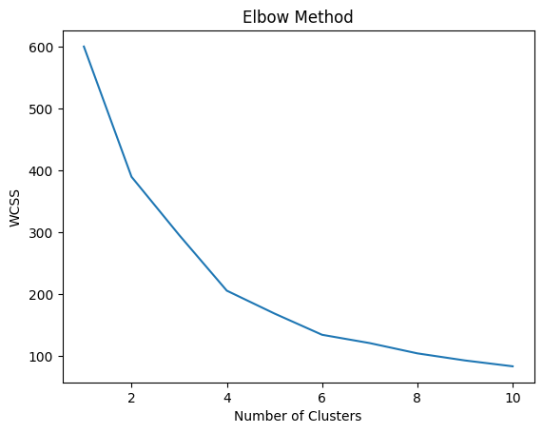/usr/local/lib/python3.10/dist-packages/sklearn/cluster/_kmeans.py:870: FutureWarning: The default value of `n_init` will change from 10 to 'auto' in 1.4. Set the value of `n_init` explicitly to suppress the warning

warnings.warn(

Age Annual Income (k$) Spending Score (1-100)

0 55.638298 54.382979 48.851064

1 32.875000 86.100000 81.525000

2 25.185185 41.092593 62.240741

3 46.250000 26.750000 18.350000

4 39.871795 86.102564 19.358974

0 47

1 40

2 54

3 20

4 39

Name: Cluster, dtype: int64

